**CS590BD Big Data Analytics and Applications**

**Lab-4 Assignment**

**By**

**Kommineni Siva Krishna**

**Summary :-**

Enhancement of the Android app developed in Lab – 3 and add the save file options during the retrieval.

Addition of motion, activity recognition patterns using the web services hosted on the servers for the training, testing and sequence file generation.

* **Enhancement of Lab- 3:-**

The following screens show the file transfer and retrieval mechanism of the data collected from the application.

It shows the file is transferred successfully.

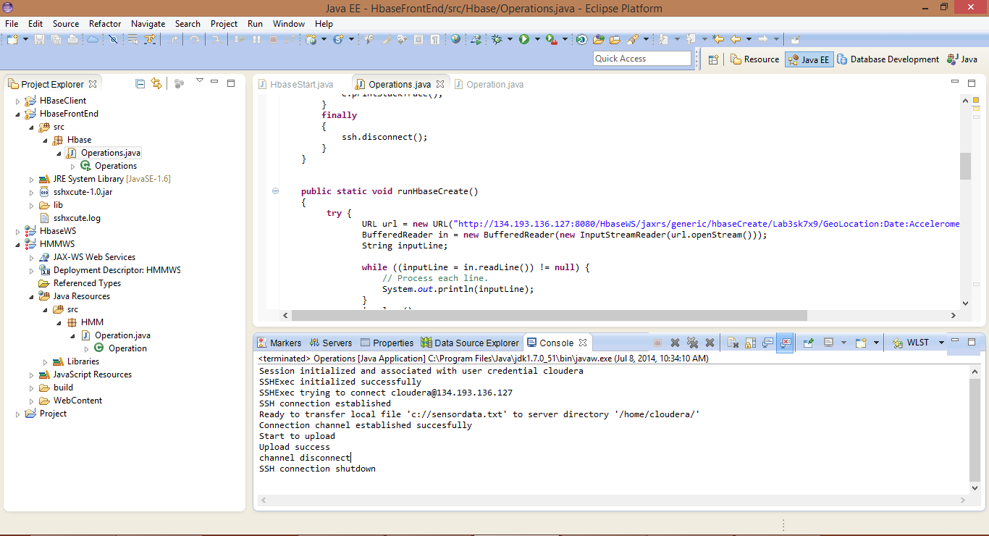

Later we retrieve the data and save the file so that the saved data files are used for the training and testing purpose.

The most important part later is the data preparation part where we prepare two files for testing and training the raw data which are tab separated.

We transfer these files to the remote machine using the file transfer mechanism to perform further operations.

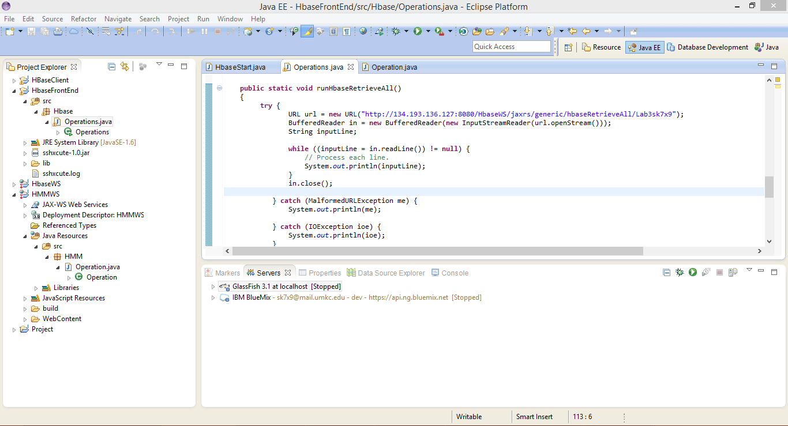

The below figure shows the UI for the Android app developed where we can perform all the HBase operations.

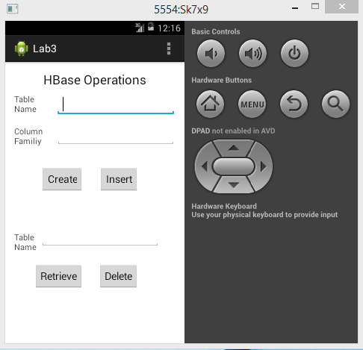 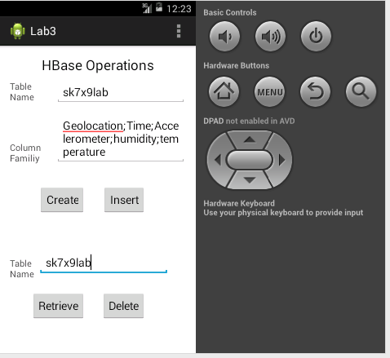

After performing all the operations we retrieve the data and store it in a file to perform the motion and activity recognition patterns.

* **Performing Activity recognition:-**

To perform the Activity recognition patterns on the given data file we first prepare the training and testing data.

Later we use K-means clustering to perform the clusters of the data based on the approximations.

Basically we use three methods in the service they are

1. Training file operations
2. Testing file operations
3. Training and testing file operations

We provide the raw data as the input file for the generation of the output sequence file as follows.

The below shows the performed training file operation for activity recognition.

We should train the system if there are more number of actions present.

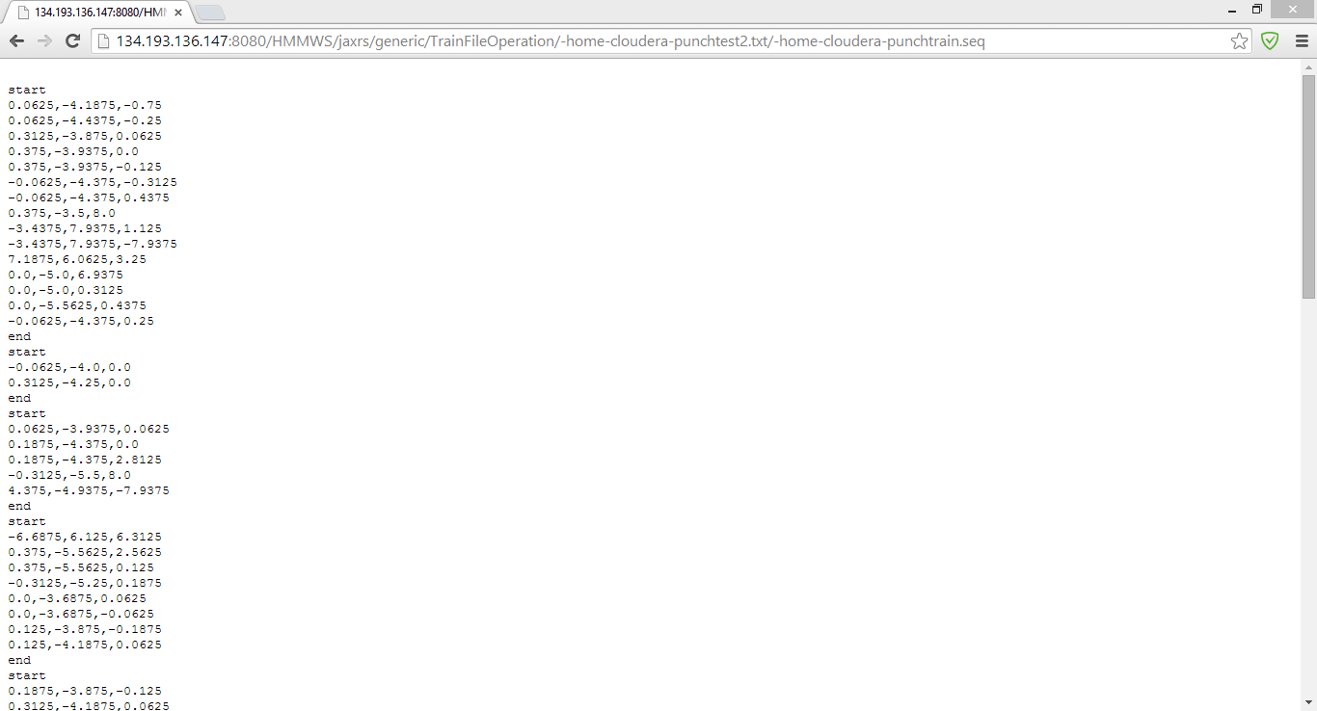

Later second operation is the generation of the output sequence file from the raw data as input.

The below screen shows the generated file after performing the testing file operations.

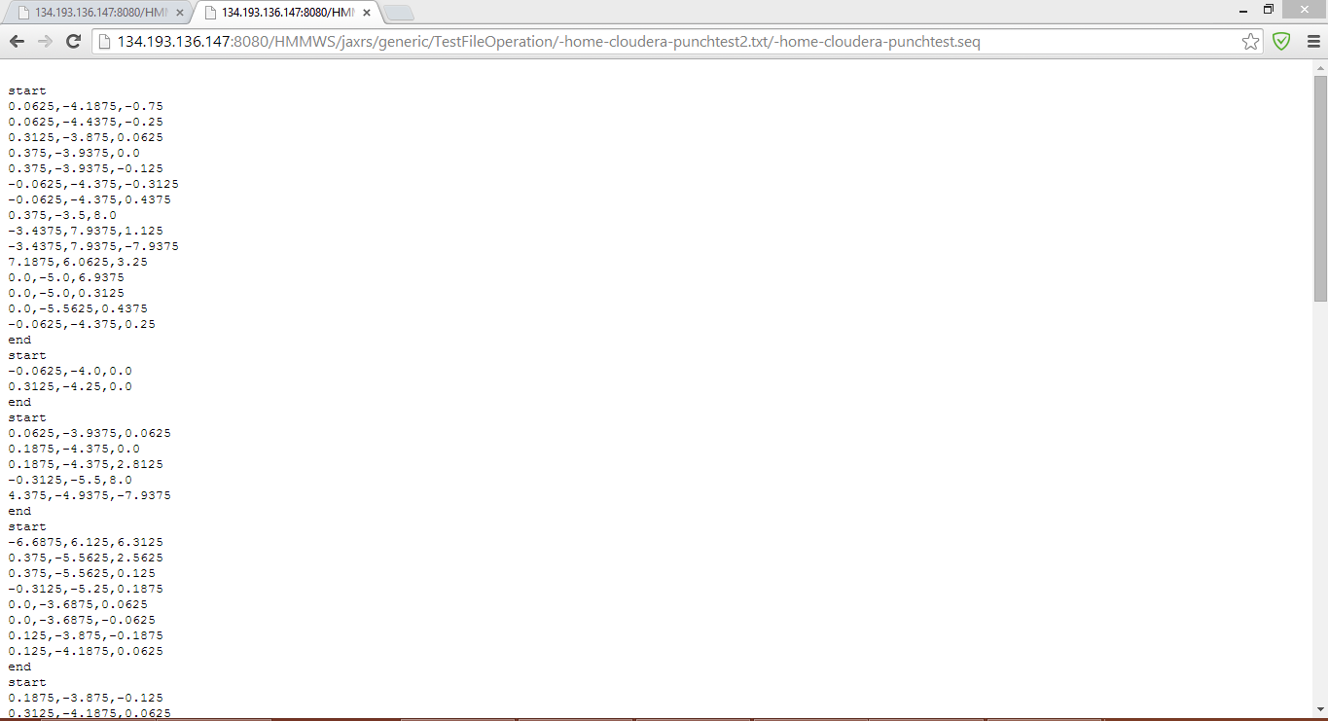

Later we perform both the training and testing operations as input sequence files to get the required output file.